**Executive Summary**

Our real estate investment group presents a compelling opportunity to capitalize on Chicago's South and West Side revitalization, leveraging the INVEST South/West initiative and the area's untapped potential.

As a licensed carpenter with extensive experience in commercial, industrial, and residential projects, I bring unique expertise to maximize property values through strategic renovations and improvements.

We are targeting properties in Chicago's South and West Side neighborhoods and immediate suburbs, areas poised for significant growth due to the city's $750 million INVEST South/West program.

This initiative aims to attract private investment, improve infrastructure, and enrich local culture, creating a favorable environment for real estate appreciation.

Our initial focus will be on 2-3 projects ranging from 650 to 990 square feet, with property acquisition costs between $25,000 and $50,000. Leveraging my carpentry skills, we plan to implement strategic renovations at $100-$250 per square foot, significantly increasing property values.

Based on current market trends and our value-add approach, we project a 60% profit margin on these initial investments.

As we establish our presence and track record, we aim to scale up to larger projects, potentially partnering with developers involved in the INVEST South/West initiative.

Key growth prospects include:

1. Capitalizing on the city's targeted investment in these areas
2. Benefiting from improved infrastructure and community amenities
3. Potential for significant property value appreciation as neighborhoods revitalize
4. Opportunity to expand into larger mixed-use developments as our portfolio grows

By combining my hands-on construction expertise with strategic investment in these emerging areas, we are uniquely positioned to maximize returns while contributing to the revitalization of Chicago's South and West Side communities.

**2 Market Analysis**

**Current State of Chicago's Real Estate Market**

* The Chicago housing market is showing resilience and growth despite some challenges:
  + Median home prices reached $360,000 in September 2024, up 7.5% year-over-year
  + Average homes sell after 59 days on the market
  + The market is somewhat competitive, with homes receiving an average of 3 offer
  + However, there's a significant housing shortage:
  + Chicago needs approximately 142,000 more homes to meet residents' needs
  + This shortage is driving up prices and creating opportunities for developers and investors.

**Specific Opportunities in the South and West Side and Suburbs**

* The INVEST South/West initiative is creating significant opportunities in these areas:
  + $750 million in city funding is being directed to revitalize these neighborhoods
  + This initiative is attracting private investment and improving infrastructure.
  + Emerging neighborhoods like Bronzeville and Bridgeport are seeing increased interest:
  + These areas offer more affordable options compared to downtown, with potential for appreciation.
  + They're benefiting from the spillover effect of downtown development and improved transit connections.

**INVEST South/West Initiative Impact**

* The initiative is catalyzing development in 10 community areas on the South and West sides:
  + It's focusing on key commercial corridors to drive economic growth.
  + The program is encouraging mixed-use developments, combining residential and commercial spaces.
* This initiative is creating opportunities for:
  + Residential developers to build new housing units.
  + Commercial real estate investors to capitalize on revitalized business districts.
  + Renovation and adaptive reuse projects in older buildings.

**Commercial and Residential Market Trends**

* Commercial trends:
  + There's growing interest in mixed-use developments, particularly in areas targeted by INVEST South/West.
  + Demand for flexible office spaces is increasing as companies adapt to hybrid work models.
* Residential trends:
  + Single-family homes in the suburbs are seeing strong demand, with prices up 7.5% year-over-year
  + [1](https://www.redfin.com/city/29470/IL/Chicago/housing-market)
  + .
  + Multi-family developments in emerging neighborhoods are attracting investors due to potential for appreciation.
  + Renovation opportunities are abundant, especially in older properties in up-and-coming areas.

**Investment Opportunities**

1. Fix-and-flip projects in emerging neighborhoods, capitalizing on the price gap between renovated and unrenovated properties.
2. Multi-family developments near transit hubs in South and West Side neighborhoods.
3. Mixed-use projects in areas targeted by INVEST South/West, combining residential and commercial spaces.
4. Affordable housing developments, addressing the city's housing shortage while benefiting from potential incentives.

This analysis suggests that Chicago's real estate market, particularly in the South and West Side areas, offers significant opportunities for investors and developers. The INVEST South/West initiative is creating a favorable environment for growth, while the overall housing shortage in the city is driving demand across various property types.

**3 Investment Strategy**

**3.1 Property Types**

* Residential: Single-family homes, multi-family units
* Commercial: Retail spaces, office buildings
* Mixed-use properties
* Fixer-uppers and value-add opportunities

**3.2 Value-Add Approach**

* Renovation and modernization strategies
* Energy efficiency improvements
* Commercial space conversions
* Leveraging carpentry expertise for cost-effective improvements

**3.3 Target Areas**

* Specific neighborhoods with high growth potential
* Proximity to planned developments or infrastructure projects
* Areas benefiting from city initiatives

**4. Group Structure and Operations**

**4.1 Legal Structure**

* LLC or LP formation details
* Roles and responsibilities of members
* Decision-making processes

**Liability Protection under LLC**

An LLC provides a crucial layer of protection for your personal assets:

* **Personal Asset Shield**: In an LLC, your personal assets are generally protected from business debts and liabilities
* [1](https://www.investopedia.com/articles/investing/091014/basics-forming-limited-liability-company-llc.asp)
* . If the business faces legal action or debt collection, creditors typically cannot pursue your personal assets like your home or savings accounts.
* **Separation of Business and Personal**: An LLC creates a distinct legal entity separate from its owners
* [3](https://www.wolterskluwer.com/en/expert-insights/singlemember-llc-vs-sole-proprietorship)
* . This separation helps maintain the liability protection, provided you keep business and personal finances separate.

**Financial Borrowing Strategies under LLC**

LLCs often have advantages when it comes to financing options:

* **Easier Access to Financing**: Many hard money or private lenders prefer lending to LLCs rather than individuals, viewing them as more stable and less risky
* [2](https://www.kiavi.com/blog/how-real-estate-investors-can-harness-the-power-of-llcs)
* .
* **Securities-Based Lending (SBL)**: As an LLC, you may have more opportunities to leverage your investment portfolio for borrowing. SBL typically offers lower interest rates compared to unsecured loans or loans against less liquid collateral
* [4](https://conversations.wf.com/cash-flow-planning/)
* .
* **Flexible Borrowing Options**: LLCs can often access a wider range of financing options, including business lines of credit and commercial real estate loans.
* **Potential for Better Terms**: Lenders may offer more favorable terms to LLCs due to the perceived stability and professionalism of the business structure.

While an LLC does require some initial setup and ongoing maintenance, the benefits in terms of liability protection and borrowing flexibility often outweigh these considerations for real estate investors. However, it's important to consult with legal and financial professionals to determine the best structure for your specific situation and investment goals.

**4.2 Membership Criteria**

* Minimum investment requirements
* Expertise and skill contributions
* Time commitments

here are some key membership roles to consider:

**Key Membership Roles**

**Project Manager**

* Oversees day-to-day operations of the investment group
* Coordinates between different team members and contractors
* Ensures projects stay on schedule and within budget
* Manages communication with investors

**Administrative Support**

* Handles paperwork and documentation
* Manages schedules and coordinates meetings
* Assists with investor relations and communication
* Maintains organized records of properties and transactions

**Real Estate Attorney**

* Provides legal guidance on property acquisitions and sales
* Reviews and drafts contracts
* Ensures compliance with local real estate laws and regulations
* Assists with entity formation and structuring

**Marketing Strategist**

* Develops branding and marketing strategies for the investment group
* Creates content for investor communications and property listings
* Manages online presence and social media accounts
* Analyzes market trends and competitor activities

**Financial Analyst**

* Conducts financial modeling and projections for potential investments
* Analyzes market data and property valuations
* Assists in creating investment proposals and reports
* Monitors financial performance of the portfolio

**Property Manager**

* Oversees day-to-day operations of acquired properties
* Handles tenant relations and lease agreements
* Coordinates maintenance and repairs
* Ensures properties remain in compliance with local regulations

**Acquisitions Specialist**

* Identifies potential investment opportunities
* Conducts initial property assessments and due diligence
* Negotiates purchase agreements
* Works closely with the project manager and attorney during acquisitions

**Construction Manager**

* Oversees renovation and construction projects
* Coordinates with contractors and subcontractors
* Ensures quality control and adherence to building codes
* Works closely with you to leverage your carpentry expertise

These roles form a strong foundation for your investor group, combining essential skills in project management, legal expertise, marketing, finance, and property operations. The project manager and administrative support roles are particularly crucial for maintaining organization and efficiency within the group.Vital contractors like attorneys and marketing strategists bring specialized expertise that can significantly enhance the group's operations and success. Their external perspective can provide valuable insights and help navigate complex legal and market landscapes.Remember, depending on the size of your group and the scope of your investments, some of these roles might be combined or expanded. The key is to ensure that all critical functions are covered to support successful real estate investments in Chicago's South Side and suburbs.

Here are some suggestions for structuring membership requirements:

**Membership Structure**

**Minimum Investment Requirements**

* **Tiered Investment Levels**: Create multiple entry points to accommodate different investor capacities:
  + Bronze Level: $5,000 - $24,999
  + Silver Level: $25,000 - $49,999
  + Gold Level: $50,000 and above
* **Flexible Investment Options**:
  + Allow members to invest in specific projects rather than requiring a general fund contribution
  + Offer the option to increase investment over time to reach higher tiers

**Expertise and Skill Contributions**

* **Skill-Based Membership**: Offer reduced financial requirements for members who can contribute valuable skills:
  + Legal expertise: Discounted investment minimum for attorneys
  + Marketing skills: Reduced buy-in for marketing professionals
  + Property management experience: Lower threshold for experienced managers
* **Knowledge Sharing Requirement**:
  + Mandate that members with specific expertise conduct quarterly workshops or training sessions for the group
  + Implement a mentorship program where experienced members guide newer investors

**Time Commitments**

* **Active vs. Passive Membership**:
  + Active Members: Higher involvement, lower investment minimum
  + Passive Members: Limited involvement, higher investment minimum
* **Time-Based Contributions**:
  + Require a minimum number of hours per month for property scouting or management
  + Offer investment credits for time spent on group activities or property maintenance
* **Meeting Attendance**:
  + Mandate attendance at quarterly strategy meetings for all members
  + Require active members to participate in monthly property review sessions

By implementing these structures, you can create a diverse and engaged membership base that leverages both financial resources and practical skills. This approach allows for broader participation while ensuring that all members contribute meaningfully to the group's success, whether through capital, expertise, or time commitment.

**4.3 Financial Structure**

* Investment tiers
* Profit-sharing model
* Capital call procedures

Here are examples of systems for determining minimum investment amounts, capital calls, and profit-sharing structures for two different project sizes. These examples will focus on property acquisition only.

**Project A: $25,000 - $75,000 Property Acquisition**

**Minimum Investment Amounts**

* Base minimum: $5,000
* Tiered system based on total project cost:
  + For projects $25,000 - $50,000: Minimum investment of $5,000
  + For projects $50,001 - $75,000: Minimum investment of $7,500

**Capital Call System**

* Initial funding: 80% of project cost
* Reserve fund: 10% of project cost held in escrow
* Capital call trigger: If expenses exceed initial funding + reserve
* Call amount: Up to 5% of original investment per call
* Maximum calls: 2 per year

**Profit-Sharing Structure**

* Preferred return: 8% to all investors
* After preferred return:
  + 70% to investors (proportional to investment)
  + 30% to managing partners

**Project B: $495,000 - $650,000 Property Acquisition**

**Minimum Investment Amounts**

* Base minimum: $25,000
* Tiered system based on total project cost:
  + For projects $495,000 - $550,000: Minimum investment of $25,000
  + For projects $550,001 - $600,000: Minimum investment of $35,000
  + For projects $600,001 - $650,000: Minimum investment of $50,000

**Capital Call System**

* Initial funding: 90% of project cost
* Reserve fund: 5% of project cost held in escrow
* Capital call trigger: If expenses exceed initial funding + reserve
* Call amount: Up to 10% of original investment per call
* Maximum calls: 3 per year

**Profit-Sharing Structure**

* Preferred return: 7% to all investors
* After preferred return:
  + 0-10% IRR: 80% to investors, 20% to managing partners
  + 10-15% IRR: 70% to investors, 30% to managing partners
  + 15%+ IRR: 60% to investors, 40% to managing partners

These structures are designed to align with the different scales of the projects while providing appropriate incentives and protections for both investors and managing partners.

The larger project (B) has higher minimum investments but offers a more sophisticated profit-sharing structure to reward outperformance.

Both systems include mechanisms for capital calls to address potential shortfalls, with limits to protect investors from excessive additional contributions.

Remember, these are example structures and should be tailored to your specific group's needs, risk tolerance, and local market conditions. It's advisable to consult with legal and financial professionals when implementing such systems.

**Here is an explanation of capital calls, their purpose and intent, as well as profit sharing structures including preferred returns:**

**Capital Calls:**

A capital call, also known as a drawdown or capital commitment, is a mechanism used by venture capital and private equity funds to collect funds from their investors (limited partners or LPs) as needed. Instead of requiring investors to contribute their entire committed amount upfront, fund managers (general partners or GPs) make capital calls when specific investment opportunities arise or when additional funds are needed for expenses.Purpose and Intent:

1. Flexibility: Capital calls allow fund managers to adapt to market changes and investment opportunities.
2. Improved fund performance: By calling capital only when needed, managers can minimize idle capital, potentially improving metrics like Internal Rate of Return (IRR) and Total Value to Paid-in Capital (TVPI).
3. Attractive to investors: LPs can hold onto their capital and potentially earn returns elsewhere until it's called.
4. Short-term financing: Capital calls bridge the gap between when financing is agreed upon and when funds are actually received.

**Profit Sharing Structure:**

Profit sharing in venture capital and private equity typically involves two main components: preferred return and carried interest.

1. Preferred Return:   
   The preferred return (often called "hurdle rate") is a minimum return that LPs receive before the GP can participate in profits. It's usually expressed as an annual percentage, often around 7-8%. For example:

* If the preferred return is 8%, LPs would receive the first 8% of profits generated by the fund.

1. After Preferred Return:   
   Once the preferred return is met, profit sharing typically follows a structure like this:

* Catch-up period: The GP receives 100% of profits until they've caught up to a certain percentage of overall profits (often 20%).
* Carried interest: After the catch-up, profits are split between LPs and GPs, typically 80% to LPs and 20% to GPs.

Example profit-sharing structure:

* 0-8% returns: 100% to LPs (preferred return)
* 8-10% returns: 100% to GP (catch-up)
* Above 10%: 80% to LPs, 20% to GP (carried interest)

This structure aligns the interests of GPs and LPs by ensuring that GPs only profit significantly when they generate strong returns for their investors.

**This example will use a preferred return structure with a waterfall distribution, which is common in real estate partnerships.**

Let's assume the following structure:

* 8% Preferred Return to Limited Partners (LPs)
* After Preferred Return:
  + 80% to LPs, 20% to General Partner (GP) until 12% IRR
  + 70% to LPs, 30% to GP until 15% IRR
  + 60% to LPs, 40% to GP for returns above 15% IRR

Example scenarios:

**Low Profit Scenario**

Total Profit: $50,000   
Invested Capital: $1,000,000

1. Preferred Return (8%): $80,000
   * LPs receive all $50,000 (100%)
   * GP receives $0

In this scenario, the profit doesn't cover the full preferred return, so LPs receive all available profits.

**Medium Profit Scenario**

Total Profit: $150,000   
Invested Capital: $1,000,000

1. Preferred Return (8%): $80,000
   * LPs receive $80,000
2. Remaining Profit ($70,000) split 80/20:
   * LPs receive additional $56,000 (80% of $70,000)
   * GP receives $14,000 (20% of $70,000)

Total Distribution:

* LPs: $136,000
* GP: $14,000

**High Profit Scenario**

Total Profit: $300,000   
Invested Capital: $1,000,000

1. Preferred Return (8%): $80,000
   * LPs receive $80,000
2. Next tier up to 12% IRR ($40,000) split 80/20:
   * LPs receive $32,000
   * GP receives $8,000
3. Next tier up to 15% IRR ($30,000) split 70/30:
   * LPs receive $21,000
   * GP receives $9,000
4. Remaining profit ($150,000) split 60/40:
   * LPs receive $90,000
   * GP receives $60,000

**Total Distribution:**

* LPs: $223,000
* GP: $77,000

This structure ensures that investors (LPs) receive their preferred return first, protecting their downside, while incentivizing the GP to maximize returns by offering increasing profit shares at higher return levels. The exact percentages and tiers can be adjusted based on the specific agreement between partners.

**5. Risk Management and Due Diligence**

* Property assessment process
* Market risk analysis
* Insurance and liability protection
* Diversification strategies

**6. Financing and Partnerships**

**6.1 Funding Sources**

* Member capital contributions
* Bank partnerships and lending options
* Government incentives and grants

**6.2 Strategic Alliances**

* Local community organizations
* City development agencies
* Real estate networks and associations

**7. Projected Returns and Exit Strategies**

* ROI projections for different property types
* Cash flow estimates
* Appreciation forecasts
* Exit strategy options (e.g., sell, refinance, hold)

**8. Team and Expertise**

* Your background and expertise
* Profiles of key team members
* Advisory board (if applicable)

**9. Legal and Compliance**

* Zoning and building code adherence
* Licensing and permit requirements
* Investor rights and protections

**10. Next Steps**

* How to join the investment group
* Upcoming property opportunities
* Contact information and Q&A session details

**11. Appendices**

* Detailed financial projections
* Case studies of successful similar investments
* Letters of intent from potential partners or properties

Hear are sample available properties and helpful links

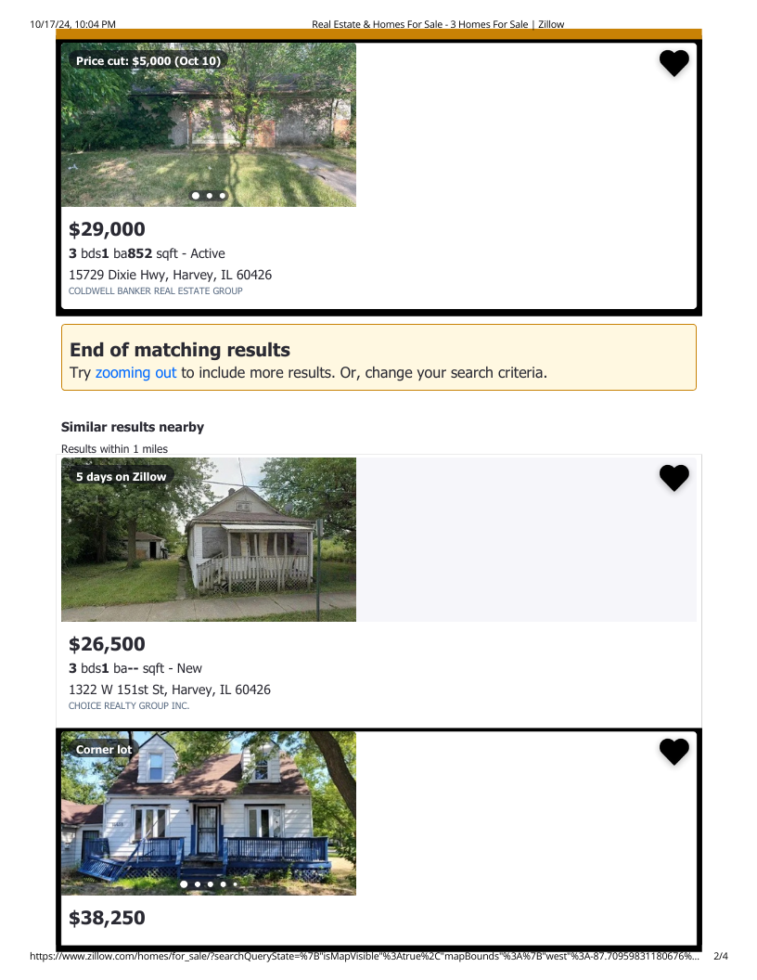

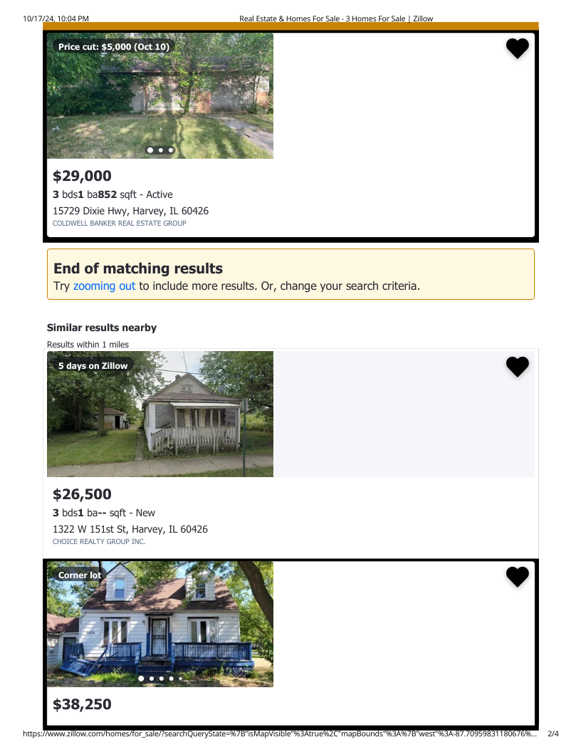

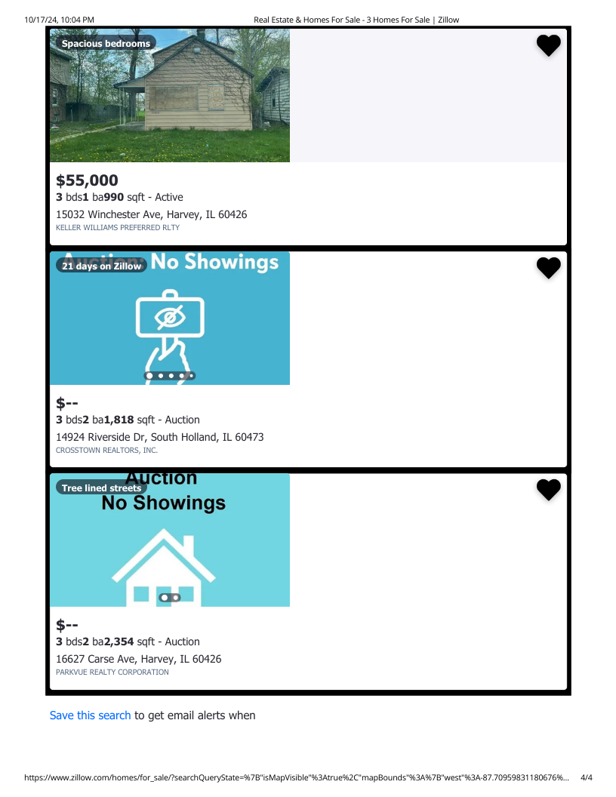

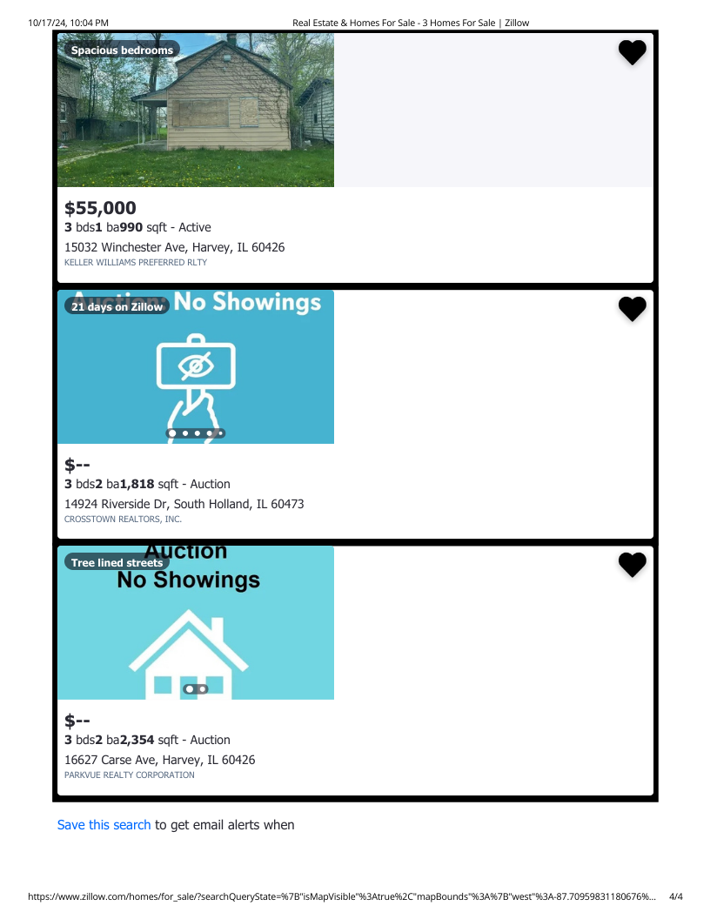

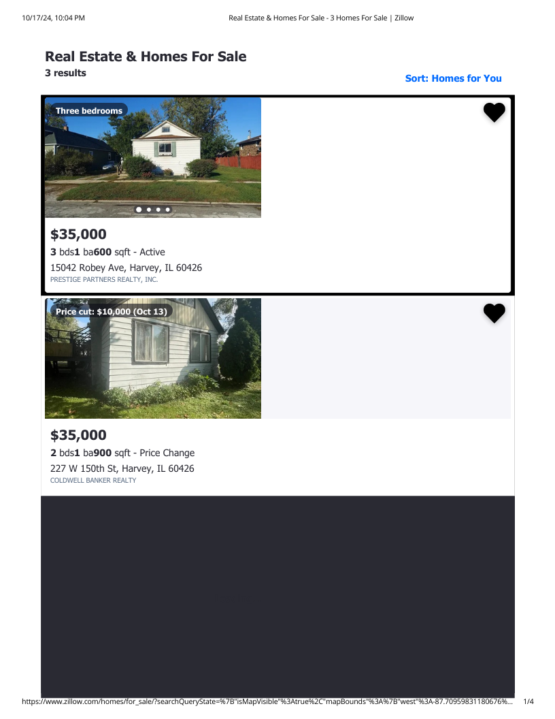

<https://public-cclba.epropertyplus.com/landmgmtpub/app/base/propertySearch?searchInfo=%7B%22criteria%22%3A%7B%22criterias%22%3A%5B%5D%7D%7D>

<https://www.zillow.com/harvey-il/foreclosures/?searchQueryState=%7B%22pagination%22%3A%7B%7D%2C%22isMapVisible%22%3Atrue%2C%22mapBounds%22%3A%7B%22west%22%3A-87.83586137858379%2C%22east%22%3A-87.58763902750957%2C%22south%22%3A41.550032623149164%2C%22north%22%3A41.670679167065856%7D%2C%22regionSelection%22%3A%5B%7B%22regionId%22%3A45676%2C%22regionType%22%3A6%7D%5D%2C%22filterState%22%3A%7B%22sort%22%3A%7B%22value%22%3A%22globalrelevanceex%22%7D%2C%22fsba%22%3A%7B%22value%22%3Afalse%7D%2C%22fsbo%22%3A%7B%22value%22%3Afalse%7D%2C%22nc%22%3A%7B%22value%22%3Afalse%7D%2C%22cmsn%22%3A%7B%22value%22%3Afalse%7D%2C%22auc%22%3A%7B%22value%22%3Afalse%7D%7D%2C%22isListVisible%22%3Atrue%2C%22mapZoom%22%3A12%7D>

**About Me**

As your dedicated consultant for establishing and growing your investor group, I offer a unique blend of expertise in data research, analysis, AI-driven strategy development, and comprehensive digital marketing. My services are designed to help you launch, manage, and scale your investment group effectively.

**Hourly Consultation Rate: $60 - $150 per hour**

This rate applies to personalized consulting services, including:

* **Investment strategy development**
* **Market analysis and opportunity identification**
* **Group structure and operations planning**
* **Risk management and due diligence guidance**
* **Financial modeling and projections**

**Service Packages:**

1. **Investor Group Launch Package**
   * Comprehensive market analysis
   * Investment strategy development
   * Legal structure recommendations
   * Initial financial projections
   * Basic digital presence setup   
     Price: $2,500 - $4,000
2. **Digital Marketing Accelerator**
   * Custom WordPress website (10-15 pages)
   * SEO optimization
   * 3 months of content creation (12 blog posts)
   * Email marketing setup with 2 campaigns
   * Social media management (3 platforms, 3 months)   
     Price: $4,000 - $6,000
3. **Comprehensive Investor Attraction Suite**
   * Advanced website with investor portal
   * 6 months of targeted content marketing
   * Email marketing automation
   * Investor presentation materials
   * Social media and PPC advertising campaigns   
     Price: $8,000 - $12,000
4. **Ongoing Investor Relations Retainer**
   * Monthly performance reports
   * Regular investor communications
   * Content creation for updates and newsletters
   * Website maintenance and updates
   * Quarterly strategy review and adjustment   
     Price: $1,000 - $2,500 per month
5. **Custom Web Application for Investor Management**
   * Tailored web application for tracking investments
   * Secure investor login and dashboard
   * Real-time reporting and analytics
   * Integration with financial data sources   
     Price: Starting at $5,000 (varies based on complexity)
6. **Investment Strategy Consultation**
   * Comprehensive market analysis
   * Competitor analysis
   * Custom investment strategy development
   * 3-month action plan
   * 2 follow-up consultation sessions   
     Price: $2,500 - $4,000

All packages can be customized to meet your specific needs and goals. My services leverage cutting-edge AI tools for strategy development and data analysis, ensuring you receive the most innovative and effective solutions for your investor group.Let's schedule a consultation to discuss how I can help you build and grow a successful investment group in Chicago's dynamic real estate market.